**Unit 1 : Lesson #6**

Factoring Quadratic Expressions

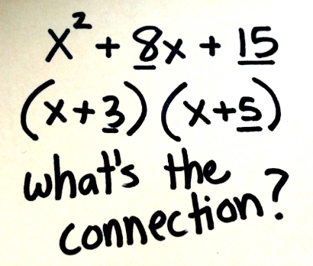

SWUT:

* A factor is a term or expression multiplied by another term or expression.
* To factor is to break down an expression into 2 or more expressions multiplied together.
* Many quadratic trinomials ( $ax^{2}+bx+c)$ can be factored into products of two binomials and that this factoring can be checked by multiplying the binomials using distributive property (FOIL).
* When factoring, they need to see the structure. Trinomial expressions can be related to basic $ax^{2}+bx+c$

4.4 Factoring Quadratic Expressions

**Objective**: *To find the common and binomial factors of quadratic expressions and to factor special quadratic expressions.*

**Factoring using the Greatest Common Factor:**

(Ex)  (Ex)  (Ex) 

**Factoring Difference of Two Perfect Squares (DOPS):** 

(Ex) x2 – 9 (Ex) 

(Ex)  (Ex) 

**Factoring Easy Trinomials in the form:** when 

(Ex) Factor: 

Reminder:

1. Draw two sets of parentheses
2. Find two numbers that add to 9 and multiply to 20
3. Check by double distributing

(Ex) Factor: 

Sometimes the will have a negative in front of it! What should you do?!

(Ex)  (Ex) 

Sometimes the trinomial will not be in the standard $ax^{2}+bx+c$ form! What should you do?!

(Ex)  (Ex) 

**Factoring by grouping: (if there are more than 3 terms!!!)**

(Ex)  (Ex) 

**Factoring Hard Trinomials in the form:** when ; two methods

“M” method “Slip and Slide”

(Ex)  (Ex) 

(Ex)  (Ex) 

**Factoring Perfect Square Trinomials:**  or 

(Ex)  (Ex)  (can use S & S or M)

(Ex) 

**Factor Completely: (Hint- Look for GCF first!)**

(Ex)  (Ex)  (Ex) 

**HOMEWORK 1-6**

